Chapter 7, Problem 37.

A circuit is described by

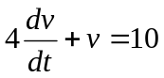.

- What is the time constant of the circuit?
- What is v(∞), the final value of v?
- If v(0) = 2, find v(t) for t ≥ 0

